Abstract

Project 1

Car Price Prediction

A company CarDekho has the data for all the cars that are present in the market.They are planning to resell the used cars in the market, but first, they want to findout what would be the price of the used cars in the market based on each car's atributes.The dataset is provided consist of cars along with the attributes of each car along with its priceThe task is to train a model that can predict the price of used cars based on the given atributes.Basically, it’s a multiclass regression problem.

Project 2

Predict Bank Churn

From the beginning, the banks are lifelines of every countries economy . everyone deposited or withdrawl money.from the bank in their life.Although pretty much everything changed in banking system from the way we deposit or withdrawl money to checking bank balances.everything seems to be fall down to our smartphones.it seems like the whole banking system is in our hands.banks have launched many services like credit card,debit card,FD and many more.if we talk about banks we have several options so predict that this customer is active customer or not with the bankis very dificult to do it manually by people but technology can do it without much efforts.In this project,Data Science and Machine Learning techiniques are used to predict wether the customer left the bank or not.It is a classification problem.

Tools / Skills Used

- Python Programming

- Jupyter Notebook

- Pandas

- Numpy

- Matplotlib

- Seaborn

- Exploratory Data Analysis

- Data Visualization

- Machine Learning

Problem Statement 1 - Introduction to the project

Car Price Prediction:

A company CarDekho has the data for all the cars that are present in the market.They are planning to resell the used cars in the market, but first, they want to findout what would be the price of the used cars in the market based on each car's atributes.The dataset is provided consist of cars along with the attributes of each car along with its priceThe task is to train a model that can predict the price of used cars based on the given atributes.Basically, it’s a multiclass regression problem.

Implementation

Workflow:

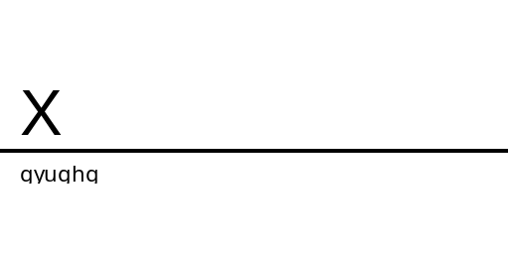
IMPORT DATA

DATA VISULATION

EDA

TEST
TRAIN

DATA PREPROCESSING

MODEL

PREDICTIONS

RESULT EVALUTION

Modelling:
- Linear Regression: Linear regression algorithm shows a linear relationship between a dependent (y) and one or more independent (y) variables, hence called as linear regression. Since linear regression shows the linear relationship, which means it finds how the value of the dependent variable is changing according to the value of the independent variable.

- Random Forest: Random forests or random decision forests are an ensemble learning method for classification, regression and other tasks that operate by constructing a multitude of decision trees at training time and outputting the class that is the mode of the classes or mean prediction of the individual trees.
Code Snippets:
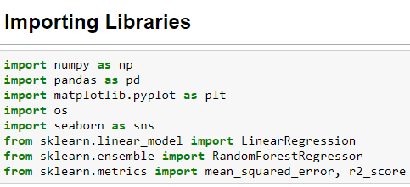

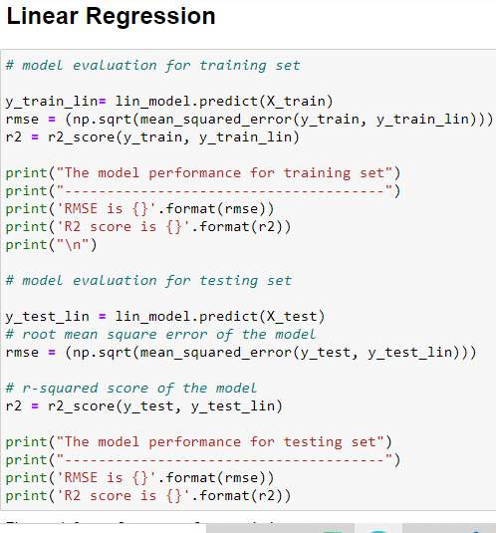

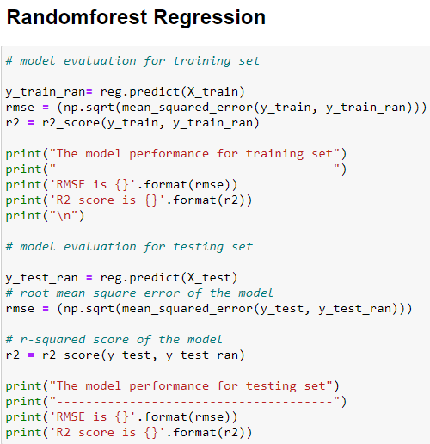
Visualization Snippets:

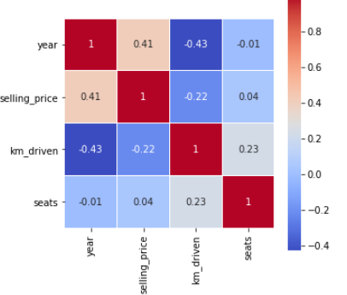

Conclusion/ Results

As a result we can say, RandomForest Regression is the best fit to this dataset, gives 83% accuracy. Linear Regression Models are not working very well on this Dataset. It gives approx. 49% of accuracy which is not good.

Future Scope

In future, the models can be upgraded with some better techniques in terms of getting higher and better accuracy, f1-score, precision, recall etc.

Problem Statement 2 - Introduction to the project

Predict Bank Churn:

From the beginning, the banks are lifelines of every countries economy . everyone deposited or withdrawl money.from the bank in their life.Although pretty much everything changed in banking system from the way we deposit or withdrawl money to checking bank balances.everything seems to be fall down to our smartphones.it seems like the whole banking system is in our hands.banks have launched many services like credit card,debit card,FD and many more.if we talk about banks we have several options so predict that this customer is active customer or not with the bankis very dificult to do it manually by people but technology can do it without much efforts.In this project,Data Science and Machine Learning techiniques are used to predict wether the customer left the bank or not.It is a classification problem.

.

Implementation

Workflow:

IMPORT DATA

DATA VISULATION

EDA

TEST
TRAIN

DATA PREPROCESSING

MODEL

PREDICTIONS

RESULT EVALUTION

Modelling:

- Logistic Regression: The logistic model is used to model the probability of a certain class or event existing such as pass/fail, win/lose, alive/dead or healthy/sick. This can be extended to model several classes of events such as determining whether an image contains a cat, dog, lion, etc.

- Random Forest: Random forests or random decision forests are an ensemble learning method for classification, regression and other tasks that operate by constructing a multitude of decision trees at training time and outputting the class that is the mode of the classes or mean prediction of the individual trees

- XG Boost: Extreme Gradient Boosting (XGBoost) is an open-source library that provides an efficient and effective implementation of the gradient boosting algorithm. Although other open-source implementations of the approach existed before XGBoost, the release of XGBoost appeared to unleash the power of the technique and made the applied machine learning community take notice of gradient boosting more generally.
Code Snippets:

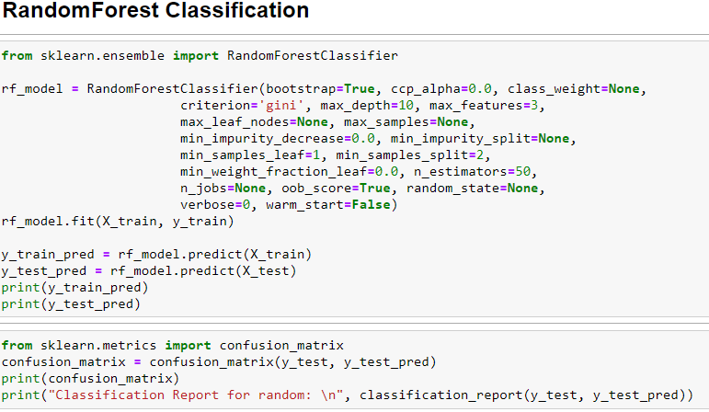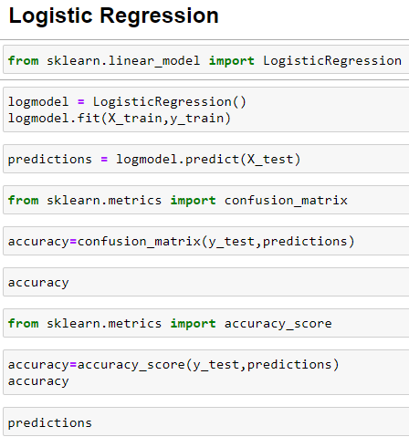

Visualization Snippets: 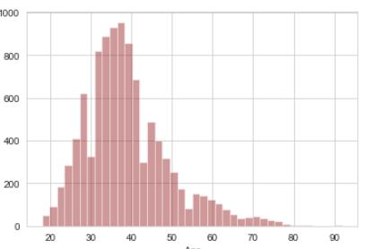

Conclusion/ Results

As a result we can say, Random Forest is performing very well. Accuracy is almost 87%. Then Logistic Regression and xgboost are also working quite well. Accuracy is almost 86% and 81%.

Future Scope

In future, better ML techniques can be used and the models can be upgraded which can give more accurate results.

